July 6, 2025

Dion Jason F. Obingayan  
371, 12th Street, Silberio Compound,  
Brgy. San Isidro, Parañaque City

To Whom It May Concern,

Good day!

I, Dion Jason F. Obingayan, 22 years old, is writing an Authorization letter to claim my NBI Clearance, Barangay Certification for First Time Job Seeker and Oath of Undertaking on July 2025. I am giving Ms. Marienell A. Mago the authority to claim these documents on my behalf.

I have enclosed my Driver’s License ID & PhilHealth ID that will work as proof of my consent on the said matter. Accompanying my IDs is Ms. Marienell A. Mago – PhilID being proof of her identification.

If you might have any concerns about this transaction, please let me know and contact me on this Mobile Number 09305789585. Thank you.

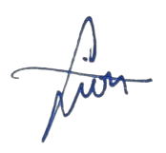

Sincerely,

Dion Jason F. Obingayan

